** Baptist Tabernacle** 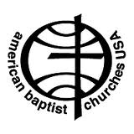

**Tabernacle Tidings**

**Baptist Tabernacle**

**63 Division Street**

**Wilkes-Barre, PA 18706**

**570 823-3083**

Website: www.wbtabernacle.com

**November 2020**

Greetings:

Despite difficulties related to the Covid pandemic, we have been trying to maintain our church worship and support services, while planning for more normalcy in the future. As part of our planning, we have entered an agreement with Valerie Black to provide pastoral services for our church as noted in the public announcement below.

_ _ _ _ _ _ _ _ _ _ _ _ _ _ _ _ _ _ _ _ _

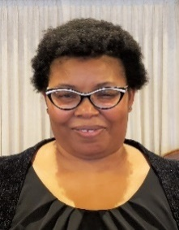 **Church Welcomes Interim Pastor**

Baptist Tabernacle in south Wilkes-Barre recently welcomed Valerie Black as its interim pastor. In this capacity, she will be leading worship and preaching, providing pastoral care and coordinating with church leadership.

Pastor Black is a native of Scranton and has worked as a probation officer for Lackawanna County since 1997. She attended Mansfield University and graduated in 1994 with a degree in Criminal Justice Administration. Pastor Black is currently a student in the Academy of Christian Training and Service of American Baptist Churches USA, an online school for individuals who want to know more about God or for those who have heard a calling and want to become certified for lay ordination. For the past several years she has provided pulpit supply in area churches and been involved with ABC’s Minister’s Council. Music is one of her passions and she loves spending time reading and watching sports.

Speaking about her new ministry, Pastor Black says, “I believe you serve God by serving His people. Therefore, I look forward to serving the members of Baptist Tabernacle.”

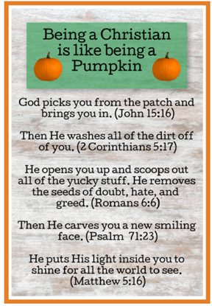

**Let Us Give Thanks**

As we make plans for the Thanksgiving holiday, we want to take time to express our gratitude and thankfulness for our many blessings. As most of you know, I am a Diabetes Nurse Educator. On reviewing a **Diabetes Living** magazine (Fall 2019), I came upon an article entitled *Attitude of Gratitude*. In our current reality related to living with the pandemic, I thought how practicing an attitude of gratitude can provide great benefit during difficult times. A simple practice of giving thanks can help you reframe and reset.

The article referenced 2017 research review that found that psychologically, being grateful has been linked with enhanced feelings of vitality, hope, optimism, and life satisfaction. In one study from this review, people who wrote down the things they were grateful for reported fewer symptoms of physical illness, had better quality sleep, and spent more time exercising than those who focused on hassles or daily events. Gratitude encourages you to build up resources, including relationships. Surrounding yourself with people who can be there when you need them not only lessens feelings of loneliness, but also makes you feel like you matter to other people.

Here are some ideas for making gratitude a daily practice. Think of one good thing to be grateful for each day. Appreciate something around you. Look for volunteer opportunities. Rather than focusing on what you cannot control, focus on what you can control. Take time to say “thank you” to people in your life who support you.

**Health Awareness:**

Flu shots are very important to protect your health – especially during the pandemic.

October was Breast Cancer Awareness month. Remember mammograms are important health screenings.

November is Diabetes Awareness month and National Nutrition month.

Risk Assessment for Pre-Diabetes:

Do you have a family history, mother, father, sister, or brother with diabetes?

Have you ever been diagnosed with high blood pressure?

You are at a higher risk for type 2 diabetes the older you are.

Certain ethnic groups are more likely to develop diabetes than others.

Being inactive increases your risk for type 2 diabetes.

Men are more likely to be diagnosed with type 2 diabetes.

Women who have had gestational diabetes are more likely to develop type 2 diabetes.

Being overweight is a major risk factor for developing type 2 diabetes.

The key to preventing diabetes is controlling weight by making healthy food choices and exercising regularly. The only way to diagnose diabetes or pre-diabetes is by having a blood glucose test which should be done yearly.

**Church Business:**

**Individual Board Meetings: Board of Deacons; Board of Education; and Board of Trustees will meet immediately following the service on the first Sunday of the month (November 1st).**

**Official Board Meeting: The Official Board will meet on Thursday, November 12th at 6 PM at the church. (Note it was decided to change the usual meeting day from Wednesday to Thursday to encourage better attendance.**

**Updates from the Official Board meeting on October 14th:**

* As noted, it was decided to have Rev. Valerie Black provide consistent pulpit supply.
* Plans are being considered for how to decorate the church for the Advent season. We are thinking about asking family groups to be responsible for various decorating tasks to limit exposure and maintain compliance with Covid guidelines.

**_____ _____ _____**

**Missions:** The mission offering collection for November and December is the **Retired Ministers and Missionaries Offering.**

The retired ministers and missionaries offering is an opportunity to support the American Baptist Churches USA as they highlight the service and ongoing impact current and retired ministers and missionaries make in the community especially during these unprecedented times. The theme for this year is *Hope for Today, Hope for Tomorrow,* and focuses on the strength and dedication of ministers, missionaries and their widowed spouses who have devoted 15 years or more to ABCUSA.

**Local Food Bank:**

Suggested items: November - coffee and tea.

December - pasta, pasta sauce, rice and dried beans

**We continue to comply with Covid Guidelines for our Sunday services and feel we have been able to maintain a safe environment and encourage you to join us for in-person worship. Sunday School is still on hold. If you decide not to attend in person, here are the web addresses for church services you can live stream.**

**First Baptist Church of Lansdale (Lansdale, PA) - with former youth pastor Chris Hamilton**

**https://www.fbcl.com/live-streaming/**

**National United Methodist Church (Washington, DC)**

**http://nationalchurch.org/live-stream**

**Shavertown United Methodist Church (Shavertown, PA)**

**https://www.shavertownumc.com/online-worship/**

**Newsletter Communication:** If you have email, please let me know so we can curtail our postage cost. (Linda@shandorf.com ; phone: 484 767-2566}.