Baptist Tabernacle 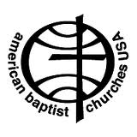
Baptist Tabernacle
63 Division Street
Wilkes-Barre, PA 18706
570 823-3083
Website:
www.wbtabernacle.com
YouTube Channel:
Baptist Tabernacle Church - WB

Tabernacle Tidings
August/ September 2021

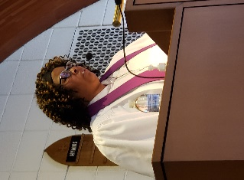
Message from Pastor Valerie
HANDLE WITH CARE
Since the beginning of 2020, people all over the world have had their lives flipped upside down. As we tried to navigate our way through this difficult time, we have tried to put on a brave face and be strong for our families, friends, churches, etc. while we fell apart on the inside. We found our mental health fractured and compromised. Kirk Franklin a Grammy, Dove, Stellar and BET award winning Gospel Artist said the following, “whenever you see a product or shipment with a sign that says handle with care, it is an attempt to inform anyone who may be in possession of it to deal with the content inside with caution and with care. Unfortunately, humans are not born with a sign on their lives that reminds whoever is in their presence that the fragility of our humanity should be handled with extreme precaution. For over a year now, we were separated, politicized, terrorized, dehumanized and now we are forced to redefine normal. Be patient, be patient as our species fails to live up to the comments on social media, on athletes navigating the demands of their fans and the protection of their souls. Because for all of us, the handle with care sign it also reflects the value of what’s inside.” Please everyone HANDLE WITH CARE.

If anyone needs pastoral support, please feel free to call or email Pastor Valerie
Phone: 570 877-2975
Email: pastorWBTabernacle@outlook.com
Rummage Sale: September 10th and 11th

“One man’s junk is another man’s treasure”
After a year off because of the pandemic, we are planning to hold our annual rummage sale on September 10 and 11. Please scour your attics, basements and closets for items you no longer need and consider donating them to help us raise money for the church’s ministries.
Items we want include:
- Clean and Gently Used Clothes (especially children’s clothes)
- Power Tools (saws, drills, sanders)
- Small Sporting Equipment (soccer balls, tennis rackets, skates)
- Bicycles
- Toys & Games & Puzzles (no broken or missing pieces)
- Household Items (dishes, glasses, small appliances in working order)
- Small Furniture (chairs, tables)
- Books, DVDs, Records (especially children’s books)
- Gardening Equipment (tools, decorative flower pots)
- Jewelry (costume watches, necklaces, rings)
- Miscellaneous (wall hangings, picture frames, quilts, linens, bedding)
Items we do not need are shoes, stuffed animals, VHS tapes, mugs, large exercise equipment (e.g., stationary cycles, etc.). Please: Not anything that is stained, torn, broken, or worn.

We also need bags (shopping and plastic or paper), boxes, and newspaper.

To arrange to drop off your items, please contact Bettie Sims or any member of the Official Board. THANKS for your support!

A Bake Sale will also be held during the Rummage Sale
Home Baked Goods are needed! Please plan to support this event by contributing your favorite homemade treats! Your efforts will be greatly appreciated.

Kid’s Discovery Day
August 28th 1 -3:30 PM
Let’s get together for an afternoon of fun as we engage the children in songs; crafts; games and of course refreshments with the underlying message that God Loves us!
Kid’s Discovery Day
August 28th 1 – 3:30 pm
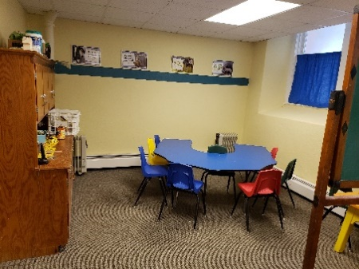
All children (and adults) are welcome
to attend an afternoon of fun…
Crafts, Games, Songs and
Refreshments
Discover what your neighborhood church can offer!
Call Linda for info (484) 767-2566

Please plan to join us for a fun filled afternoon. Any help is appreciated. Please come around 12 PM to help with preparation and set up. We are reaching out to families in the neighborhood and hope that the children will come. This is a great opportunity to let people know that we are here to serve the needs of the community and hopefully we can spark interest in joining our church family.
- - - - - - -
Rally Day – Sunday, September 19th
We are planning an all – in – one Sunday School after morning worship (11:00 AM - 12:00 PM) each week. The program will include refreshments; songs; a Bible message and a craft. We will plan to stay upstairs in the main sanctuary. Hopefully the children will find the time to be fun and enjoy spending time together learning Bible stories and songs.
- - - - - - -

Congratulations and thanks to Ron Shandorf who applied for and received a grant from ABCOPAD: ”Release God’s Power”.
As you are aware, we began Live Streaming our services using YouTube and equipment loaned by one of our trustees. However, our viewers have commented that they experience difficulties hearing and reading the lyrics and scriptures. As we move forward, we believed we needed to invest in our Live Streaming capabilities in order to serve our existing membership as well as add members from the multi-cultural neighborhood we serve.
Additionally, we needed to find a way to properly serve our remote, elderly and shut-in members who have no resources to attend services whether in person or virtually. This grant application supports improved innovations including use of iPads and Internet “HotSpots”. A one-time expense to purchase equipment including Cameras, Laptop, and Audio/Visual controller in addition to monthly expenses for upgraded internet service were desired.
The ABCOPAD grant for ~ $6,000 was approved and the funds have been received.
Subsequently, we were informed that ABCOPAD had additional funds available so Ron applied for a 2nd grant for ~ $2,000. “We find that if we can obtain additional funds, we can purchase an upgraded camera and controller to truly have excellent quality Live Streaming without having cameras positioned to obstruct congregants view during the services.” This 2nd Grant is still pending as of today but the Trustees made a motion to purchase this upgraded camera in anticipation of an approval.
Ron has been busy upgrading our internet services and electronic capabilities. He has installed the new cameras and is working on configuring the new iPads that will enable our shut-ins to view the live streaming services. He plans to instruct the users regarding how to use the new equipment.
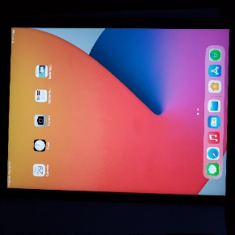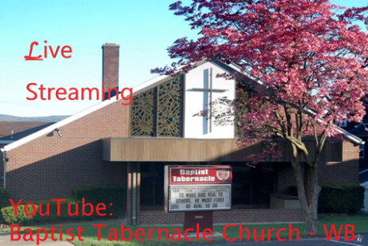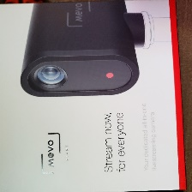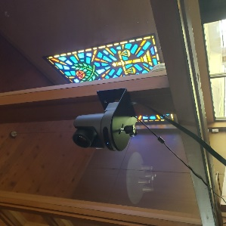

Updates from the Official Board:
Board Meetings will be resuming in September.
Individual Boards will meet on Thursday, September 9th at 6 PM with the Official Board Meeting to follow at 6:45 PM.

Covid-19 Update:
Though not required, current Covid Guidelines recommend that masks be worn by both vaccinated and unvaccinated people when indoors in order to reduce the risk of transmitting the virus.

Our goal is to provide a safe opportunity for as many people as possible to participate in the Sunday worship service. Live-streaming will continue for those who are unable to participate in-person.
Communion
If anyone is interested in receiving communion at home, disposable communion cups are available and can be picked up at the church. Contact Ron Shandorf or Bettie Sims to make arrangements to pick up communion cups. Pastor Valerie can offer communion via phone or arrange for a personal visit for our shut-ins.

Live Streaming Services:
Live streaming can be done on any internet device including smart phones; iPads; tablets; or computers. If you have any questions about how to access live streaming, you can call Ron Shandorf at 610 462-8476.
To access the live streaming, you can choose one of two options:
- Go to the church website: wbtabernacle.com and click on the link for live streaming. You can choose the service you would like to view.
- Go to Youtube and search for “Baptist Tabernacle Church-WB”. You can select the service you would like to view.

Birthdays and Anniversaries: August
1 Jane Tudgay 19 Cindy Saltz
7 Isabelle Cannavale 20 Charlotte Blaine
9 Jody Finnegan 24 Bob & Elaine Singer (anniv.)
10 Earl Kohl 24 Donna Ostrander
18 April Marcincavage 26 Merissa Sims
19 Bob Singer 31 Don Ostrander
September
10 Mary Hauer
13 Don & Donna Ostrander (anniv.)
21 Ron Shandorf
23 Cloe Gudaitis
Please remember our members who are sick or shut-in by sending greeting cards.
Arlene Ebert and Vivian Wickheiser are at home. Beatrice Murray remains at Timber Ridge Nursing Home.

Key Contact Info:
Website: wbtabernacle.com
YouTube Channel: Search YouTube for “Baptist Tabernacle Church-WB”
Facebook: Search for “Group” = “Baptist Tabernacle” and Join the group
Name Email Address Phone #
Pastor Valerie Black PastorWBTabernacle@Outlook.com (570) 877-2975
Tech issues – Ron Shandorf IT.WBTabernacle@Gmail.com (610) 462-8476
Bea Fell BeaFell93@Gmail.com (570) 301-8073
Don Ostrander Dgunnyo@Comcast.net (570) 817-6835
Janet Murray JanetMurray07@Gmail.com (914)260-9066

