Baptist Tabernacle 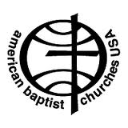
Baptist Tabernacle
63 Division Street
Wilkes-Barre, PA 18706
570 823-3083
Website:
www.wbtabernacle.com
YouTube Channel:
Baptist Tabernacle Church - WB

Tabernacle Tidings
June 2021

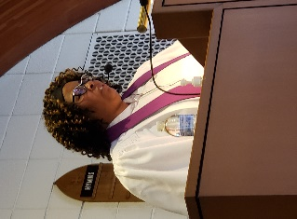
Message from Pastor Valerie
WE CELEBRATE YOU
Well, it is that time of year when the students are graduating from Pre-School to Kindergarten, from Kindergarten to Elementary School, from Elementary School to Middle School, from Middle School to High School, from High School to the work force or higher education, or from higher education and beyond. To put it simply it is graduation season and we at Baptist Tabernacle are so proud of all oour graduates.
On behalf of the officers and members of Baptist Tabernacle Church congratulations! We are so immensely proud of each and everyone of you. We know that this past year has been an unconventional challenge to all of the students, who had to exercise such tenacity and determination to meet their goals. So, let us celebrate you and your accomplishments on June 13, 2021 during our 9:30 AM Sunday Morning Worship Service.
Again, congratulations and may God continue to bless you as you continue to reach higher and higher.
Pastor Valerie Black

If anyone needs pastoral support, please feel free to call or email Pastor Valerie
Phone: 570 877-2975
Email: pastorWBTabernacle@outlook.com
Please plan to attend church on Sunday, June 13th
We are planning a special recognition for all the children and graduates!
Bibles will be presented to Anna Murray and Bethany Saltz.
Recognizing Our Graduates
It’s time to acknowledge the accomplishments of our young people, whether they are graduating from high school, college or post graduate studies. We want to recognize their achievements and encourage continued pursuit of their life goals with the understanding that with God’s help, they can achieve anything.
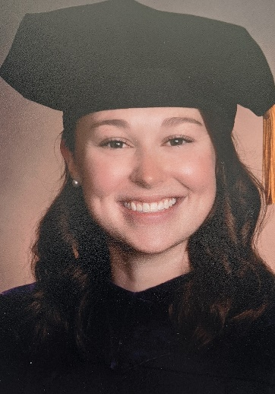
Rachel Finnegan
Daughter of William and Jody Finnegan, Granddaughter of Sandra Bonavina
- Graduated from St. Nicholas – St. Mary’s Elementary School in 2010
- Graduated from Holy Redeemer High School in 2014
- Graduated from Misericordia University in 2018 with a Bachelor’s in Government, Law, and National Security and a Minor in Psychology
- Graduated from Widener Commonwealth Law School in 2021 with a Juris Doctorate
  - I intend to practice Family Law or Collaborative Law in NEPA.
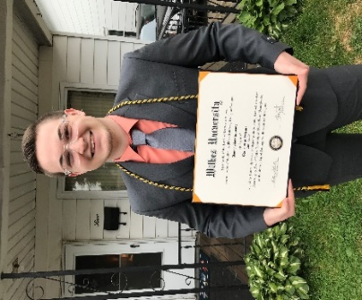
Danny Marcincavage
Son of Tammy Marcincavage and the late Anthony Marcincavage.
- Past graduate Hanover Area High School (2017).
- Recent Graduate of Wilkes University with a Bachelor of Science Degree in Biochemistry
- Plans to attend Geisinger Commonwealth School of Medicine for Master’s in Biomedical Science
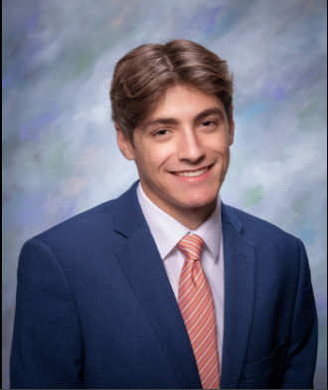
Jeffrey DeRocco Jr.
Son of Jeffrey and Tracey DeRocco and Grandson of Sandra Bonavina and the late Joseph Bonavina Jr.
- Attended Hanover Area School District from K-12.
- Participated in Cross Country, Swimming, Track & Field, and Volleyball throughout High School.
- 6 time district medalist in Swimming.
- Hanover Area's June Student of the Month.
- Works a part-time job at Gerrity's Supermarket in Hanover Twp.
- Will be attending Shippensburg University and majoring in Elementary Education.

Congratulations to Pastor Valerie. She will be receiving certification as a lay pastor on Sunday, July 11th, 3 - 4 PM at United Baptist Church in Taylor, PA. Members of Baptist Tabernacle are invited to attend.
June 13th National Children’s Day

NATIONAL CHILDREN’S DAY HISTORY
Reverend Dr. Charles Leonard of the Universalist Church of the Redeemer in Chelsea, Massachusetts started Children’s Day in 1856 as a special day to Baptize children. He originally named it Rose Day. In 1995, President Clinton proclaimed National Children’s Day as October 8th. He was later followed by President Bush in 2001 who declared the first Sunday in June as National Child’s Day. However, National Children’s Day is generally celebrated the second Sunday in June or October 8th.

The day honors the children in our lives by slowing down our fast-paced lives, turning off the tech, and refocusing on the important things. Taking one day may not be enough but using it as an opportunity to redirect our family’s lives may be an important step in a child’s life. Children look up to the adults in their lives for guidance. While their personalities are unique, they develop their character as they spend time with you and me.

Child Quotes: Adapted from National Day Calendar
A child can ask a thousand questions that the wisest man cannot answer. Jacob Abbott
Children are mirrors they reflect back to us all we say and do. Pam Leo
It is easier to build strong children than to repair broken men. Frederick Douglas
Adults are just outdated children. Dr. Seuss

HOW TO OBSERVE National Children’s Day
Cherish our children, spend time with them. Seize the opportunity to spend time with your children and grandchildren.

Make it your mission to:
Start new traditions. Open your heart to new ideas.
Explore the outdoors. Listen to your children.
Tell family stories. Seek adventure with your children.
Be creative through art or music. Break out of old routines.
Teach them something new. Pursue new opportunities with your children.

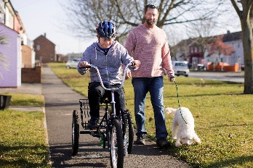
June 20th Happy Father’s Day
Happy Father’s Day to all the men in our church family who have been blessed with the privilege of raising children and serving as a role model for their development.

In Catholic Countries in Europe, Father’s Day has been celebrated as St. Joseph’s Day on March 19th since the Middle Ages. In the United States, Father's Day is celebrated on the 3rd Sunday of June.
In 2021 Father’s Day is on June 20th. Father's Day is a great opportunity to appreciate the love and effort of our fathers.

Children - Remember to tell your father how much you love him and appreciate everything he does for you!

Thrive Women’s Conference
Mark your calendars and plan to participate in this year’s Women’s Conference on June 18th (evening) and 19th (9 AM – 12:30 PM) which is being held virtually.
If you are interested in attending, you can go to our Baptist Tabernacle website wbtabernacle.com and click on the link to the website for the Registration form, Conference Mission Project and Keynote Speaker info.

Packing Suitcases for Brazil
Please remember to support the American Baptist Women of Pennsylvania and Delaware by donating items that will be delivered to Brazil to support the Hope Unlimited project. This is a program that provides comprehensive residential care for student-aged children who have nowhere else to turn. The children come from the worlds of sex trafficking, drug running, incarceration, and life on the streets. It provides guidance, education, and training for future employment.
You can help Women on a Mission with our project. We are looking for things to be sold in the thrift shop in Brazil that helps fund Hope Unlimited.
We will be collecting IN GOOD CONDITION ONLY costume jewelry, hand-made items (e.g., crocheted doilies, embroidered pillowcases, fancy towels, decorative knickknacks, etc.), reading glasses (with cases would be helpful), ladies’ handbags, high-heeled shoes, and NEW children’s clothing (newborn and up). It would be especially helpful if your items were placed in good condition plastic containers. If possible, wrap your items in tissue paper or bubble wrap and put them in the containers. You may put a note in the container about the contents (e.g., “bracelets, “doilies,” etc.) but please do not write on the containers as they will be resold at the thrift store.
The plan is to fill good condition used suitcases with the plastic containers and their contents. They will then be transported as extra luggage by those who travel back and forth between the US and South America for business.
Any help you can provide with this project will be greatly appreciated and the impact will be impossible for us to measure. But God will use it and multiply what your loving hearts provide. If you have any questions, please see Barbara Nanstiel or Pastor Val.

Rummage Sale: Planned for September
Please start collecting your unwanted clothes and household items which can be dropped off at the church in anticipation of the Rummage Sale. You can call Bettie Simms if you want to drop off items at the church.

Covid-19 Update:
The Guidelines have changed! If you are fully vaccinated, masks are no longer required. Please plan to join us again for in-person worship!
Our goal is to provide a safe opportunity for as many people as possible to participate in the Sunday worship service. Live-streaming will continue for those who are unable to participate in-person.

Communion
If anyone is interested in receiving communion at home, disposable communion cups are available and can be picked up at the church. Contact Ron Shandorf or Bettie Sims to make arrangements to pick up communion cups. Pastor Valerie can offer communion via phone or arrange for a personal visit for our shut-ins.
Live Streaming Services:
Live streaming can be done on any internet device including smart phones; iPads; tablets; or computers. If you have any questions about how to access live streaming, you can call Ron Shandorf at 610 462-8476.
To access the live streaming, you can choose one of two options:
- Go to the church website: wbtabernacle.com and click on the link for live streaming. You can choose the service you would like to view.
- Go to Youtube and search for “Baptist Tabernacle Church-WB”. You can select the service you would like to view.

Updates from the Official Board:
The Ring Security System has been installed.
Board Meetings for June: June 10th
Individual boards meet at 5:15 PM
Official Board meets at 6 PM

Birthdays and Anniversaries: June
2 Bill Wischnewski 11 Mary Cannavale
5 Rachel Finnegan 16 Janet Murray
5 Ella Grilz 17 Sandra J. Bonavina
6 Mason DeRocco 21 Larry and Cindy Salta (anniv.)
7 Tracey DeRocco 22 Sara Miscavage

Please remember our members who are sick or shut-in by sending greeting cards.
Arlene Ebert and Vivian Wickheiser are at home. Beatrice Murray remains at Timber Ridge Nursing Home.

Key Contact Info:
Website: wbtabernacle.com
YouTube Channel: Search YouTube for “Baptist Tabernacle Church-WB”
Facebook: Search for “Group” = “Baptist Tabernacle” and Join the group

Name Email Address Phone #
Pastor Valerie Black PastorWBTabernacle@Outlook.com (570) 877-2975
Tech issues – Ron Shandorf IT.WBTabernacle@Gmail.com (610) 462-8476
Bea Fell BeaFell93@Gmail.com (570) 301-8073
Don Ostrander Dgunnyo@Comcast.net (570) 817-6835
Janet Murray JanetMurray07@Gmail.com (914)260-9066

