Baptist Tabernacle 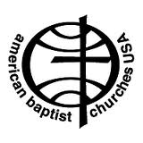
Baptist Tabernacle
63 Division Street
Wilkes-Barre, PA 18706
570 823-3083
Website: www.wbtabernacle.com
YouTube Channel: Baptist Tabernacle Church – WB
Email: Pastgor.WBTabernacle@Gmail.com

Tabernacle Tidings
October/ November 2021

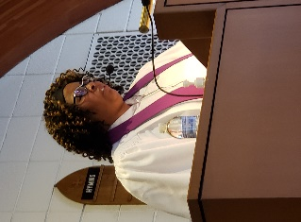
Message from Pastor Valerie
BREAST CANCER AWARENESS MONTH
As everyone may know, the month of October is Breast Cancer Awareness Month. During this month, everyone is encouraged to do self-checks of their breast and get mammograms because the key to surviving this horrible disease is early detection. This subject hit very close to home because my aunt Charlotte, who raised me since I was six months old, and my cousin, Simone Baldwin are survivors. More recently, my co-worker Lisa and a woman from my mother’s church, Rosa were diagnosed with this disease, but due to early detection their prognoses are very good. Both of these ladies are currently undergoing post operation treatment. As the interim pastor of Baptist Tabernacle, I want to encourage everyone to do self-checks and get a mammogram. Please do not wait, I know people who waited and it was too late. It is my prayer that we pay attention to our bodies, any abnormalities that may arise, and go to the appropriate doctor to be examined.
Love you guys!
Pastor Valerie
Please remember to wear PINK on
Sunday, October 24th!!

If anyone needs pastoral support, please feel free to call or email Pastor Valerie
Phone: 570 877-2975
Email: Pastor.WBTabernacle@Gmail.com

Pastor Val is planning a Bible study to review the book by Tony Evans entitled Victory in Spiritual Warfare … Field Guide For Battle.
The study group will meet on Wednesday evenings 7 - 8:30 PM for two 4 week sessions. Beginning next week (October 20th).
This is Basic Training for spiritual warfare based on scripture.
Corinthians 10:4-5 New King James Version
For the weapons of our warfare are not carnal but mighty in God for pulling down strongholds, casting down arguments and every high thing that exalts itself against the knowledge of God, bringing every thought into captivity to the obedience of Christ,
Please let Pastor Val know if you are interested in participating.

Seasons Change…
Summer is over… It’s time to appreciate the beauty of the Autumn season! We are fortunate to live in an area where we can appreciate the four distinct seasons. Changes that occur in the cycle of life are most obvious at this time of year as we watch the leaves turning from green to various shades of yellow, orange, and red before falling from the trees in preparation for the winter sleep. The mountains provide us with beautiful vistas and breathtaking views.
ENJOY!!
This Photo by Unknown Author is licensed under CC BY-NC-ND
Time Passes…
It’s hard to believe that we’ve been dealing with Covid pandemic for more than a year now (actually since April/ March 2020). I’ve been writing the monthly Tabernacle Tidings newsletter now since July 2020. I must admit though, I thought it was a temporary effort to help keep our church members informed during this time of isolation.
Science has provided us with so much more knowledge about Covid as well as vaccines that are extremely effective in preventing the spread. Most members have received the vaccine as advised, and we have been following all the CDC recommendations to keep everyone safe while coming together for Sunday worship and meetings.
We have about 12 members who have been consistently attending, but we keep hoping more will return. If you have been thinking about returning to in-person worship, we encourage you to do so. We miss seeing everyone. There’s something special about coming together for worship and praise. You also feel the support and comfort of talking with friends.
Absence does not necessarily make the heart grow fonder… sometimes the longer you avoid doing something, you find yourself “out of the habit”, and it’s harder to get back to the old routine. What about you? Are you able to go to the store, out for dinner or an in-person doctor visit? Perhaps you could also manage an hour for Sunday worship.
We have also put a lot of effort into the live streaming effort for our members, but unfortunately very few, and lately no one is taking advantage of this service. Note: we have had some recent problems with the audio transmission, but Ron has been able to correct the problem. If you are unable to come to church, we sincerely hope that you will watch the service on YouTube. If you do not have access to the internet or technology that will allow you to view the services, please contact Ron Shandorf. He can provide you with the needed technology and internet access and explain how to use it, so there is no excuse why everyone cannot participate in the Sunday worship. Remember, we have loaner equipment that we can provide, so there is no reason not to give it a try.

World Mission Offering is being collected through the end of October.
The theme for this year (“We’ve been surprised by God’s glory”) is a celebration of the ways in which we’ve seen God enter into the grief and difficulties of our pandemic year to provide support for our global partners as they faced food scarcity and critical needs during the pandemic. In dark, lonely and difficult times, God has surprised us with hope and provision. Please continue to keep the global servants in prayer.

White Cross Yesterday and Today
Throughout its life our church has always strongly supported the mission outreach of our denomination. For many years one of the arms of our efforts was The Women’s Guild, which promoted the White Cross program of American Baptist Women. In 2004 a second women’s circle was formed because many of the younger women worked full time outside the home and were not able to attend the daytime meetings. When the time came that the Women’s Guild was dissolved because of the passing of its members, Women on a Mission continued the work of the earlier group, assuring that the White Cross cause would continue. We ladies enjoyed a shopping trip on a Saturday in each October to purchase the items requested by the “home” mission program that had been assigned to us by our region officers. We purchased school supplies, craft materials and games, clothing, and other items that provided direct support for Christian centers, children’s homes and hospitals throughout the United States and Puerto Rico. In addition, we made a monetary contribution to a designated “overseas” mission project.
Unfortunately, the Covid19 Pandemic necessitated a change from the traditional format for White Cross. We no longer received a list of requests lists from a home mission location, but the tradition of extending outreach was transformed into our selecting a ministry that we wish to support and making a financial gift for them to use for their needs. Women on a Mission chose to continue our support of the Crossroads Community Baptist Church in Erie, Pennsylvania, from which we had received requests for the previous two years. And we sent a check to the White Cross General Fund and our national AB Women officers decided where those funds could best be used from the many projects in countries such as Burundi and Thailand and others around the globe.
At a recent meeting of Women on a Mission, members decided to make the same contributions ($150 to the Crossroads church and $300 to the WC General Fund) for 2021.
We are SO grateful for your support to this worthy cause in the past. If you wish to make a donation this year, please see one of the members of Women on a Mission.

Sunday School for Kids
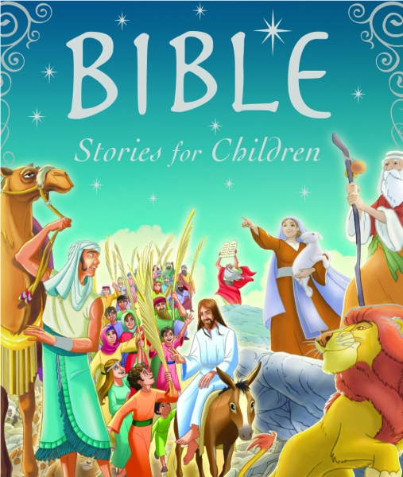
This Photo by Unknown Author is licensed under CC BY-NC-ND

Sundays 11:00 AM – 12:00 PM
September 19 (Rally Day) February 13; 27
October 3; 17; and 31 March 13; 27
November 7; 21 April 10; 24
December 5; 19 May 8; 22
January 2; 16; 30 June 5; 19
Songs Bible Lessons Crafts Games
Traditional Sunday School has not worked well in the past due to limited attendance. It was decided to offer Sunday School for all ages: 2 weeks/ month with simple format to include Bible Lesson; songs; games; crafts and snacks.
This new format seems to be working well. The kids are having fun and hopefully learning basic Bible lessons. We are hopeful that attendance will increase!
We are planning a little Halloween party at the Oct. 31st Sunday School session and encourage everyone to dress up as a Bible character!

Updates from the Official Board:
Trustees are working on improving the church property and building issues, if you have any concerns or notice anything that needs attention please contact a member of the board. Recent improvements include removal of shrubs from Division street side of church and purchase and installation of a new utility shed.
Individual Boards will meet on Thursday, October 14th at 6 PM with the Official Board Meeting to follow at 6:45 PM.
November meetings: Thursday, November 11th

Covid-19 Update:
Though not required, current Covid Guidelines recommend that masks be worn by both vaccinated and unvaccinated people when indoors in order to reduce the risk of transmitting the virus.

Our goal is to provide a safe opportunity for as many people as possible to participate in the Sunday worship service. Live-streaming will continue for those who are unable to participate in-person.

Communion
If anyone is interested in receiving communion at home, disposable communion cups are available and can be picked up at the church. Contact Ron Shandorf or Bettie Sims to make arrangements to pick up communion cups. Pastor Valerie can offer communion via phone or arrange for a personal visit for our shut-ins.

Live Streaming Services:
Live streaming can be done on any internet device including smart phones; iPads; tablets; or computers. If you have any questions about how to access live streaming, you can call Ron Shandorf at 610 462-8476.
To access the live streaming, you can choose one of two options:
- Go to the church website: wbtabernacle.com and click on the link for live streaming. You can choose the service you would like to view.
- Go to YouTube and search for “Baptist Tabernacle Church-WB”. You can select the service you would like to view.

Birthdays and Anniversaries: October
3 Fritz Cannavale 12 Beatrice Murray
4 Larry & Sara Miscavage (anniv) 22 Vivian Wickiser
7 Margaret Bullock 29 Paul Durko
8 Matt & Amy Cannavale (anniv) 30 William and Jody Finnegan
10 Anthony Cannavale (anniv)

November
5 Paula DelPrete & Paul Durko (anniv) 27 Sharon Myers
10 Janet Cussatt 28 Linda Shandorf
13 Marcus Gudaitis 30 Matthew Cannavale
18 Noah Cussatt

