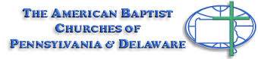 Baptist Tabernacle 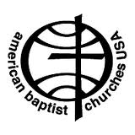
Baptist Tabernacle
63 Division Street
Wilkes-Barre, PA 18706
570 823-3083
Website: www.wbtabernacle.com
YouTube Channel: Baptist Tabernacle Church – WB
Email: Pastgor.WBTabernacle@Gmail.com

Tabernacle Tidings
November/ December 2021
Happy Holidays
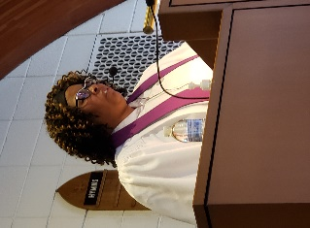

Message from Pastor Valerie
THIS HOLIDAY SEASON
During this holiday season I would like to encourage everyone to not get stressed out by putting an emphasis on the physical and temporal things. Instead, let us focus on the true meaning of this holiday season, thanking God for all that He has done for us and celebrating the birth of His Son, Jesus, who came into the world as a baby born in a manger. With all of the advertisements and Christmas music that we are bombarded with it is very easy to get caught up and lose sight of what is really important.
Last year, we were unable to gather with our families and friends during the holidays and some even battled depression as a result. This year, however, we are able to come together and experience that familial bond again. That in itself is something to be thankful for. So, let us thank God for the gift of life, health, and happiness. Let us come together and celebrate the love, joy, peace and hope that the Christ Child brings into our lives. Remember Jesus is the Reason for the Season.
Holiday Blessings,
Pastor Valerie Black
If anyone needs pastoral support, please feel free to call or email Pastor Valerie
Phone: 570 877-2975
Email: Pastor.WBTabernacle@Gmail.com

As we celebrate Thanksgiving with our families, our hearts are thankful and joyful as we begin preparation for the Christmas holiday season.
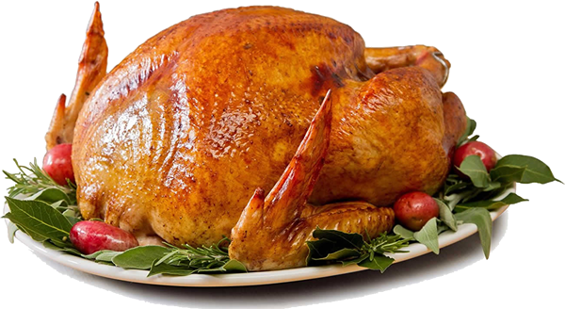
This Photo by Unknown Author is licensed under CC BY-NC
Fasting and Feasting Prayer
Fast from judging others…
Feast on finding God in them.
Fast from harsh or mean words…
Feast on words that encourage and support others.
Fast from anger…
Feast on patience.
Fast from worry…
Feast on God’s love and care.
Fast from complaining…
Feast on appreciation.
Fast from bitterness, resentment or jealousy…
Feast on forgiveness and acceptance.
Fast from self-centeredness…
Feast on compassion for others.
Fast from discouragement…
Feast on hope.
Author unknown

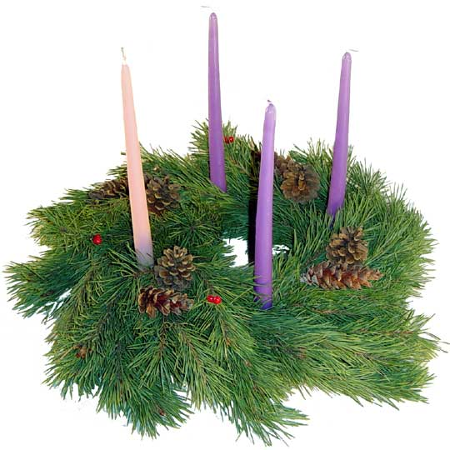

Advent, from Latin adventis, means “coming”.
The four Sundays preceding Christmas are recognized for four virtues. The candles on the Advent wreath symbolize hope, love, joy and peace.
Advent is a period of spiritual preparation in which many Christians make themselves ready for the coming birth of the Lord, Jesus Christ. Celebrating Advent typically involves a season of prayer, fasting, and repentance followed by anticipation, hope, and joy.
Many Christians celebrate Advent not only by thanking God for Christ’s first coming to Earth as a baby, but also for his presence among us today through the Holy Spirit and in preparation and anticipation of his final coming by the end of the age.
-------------------------------------
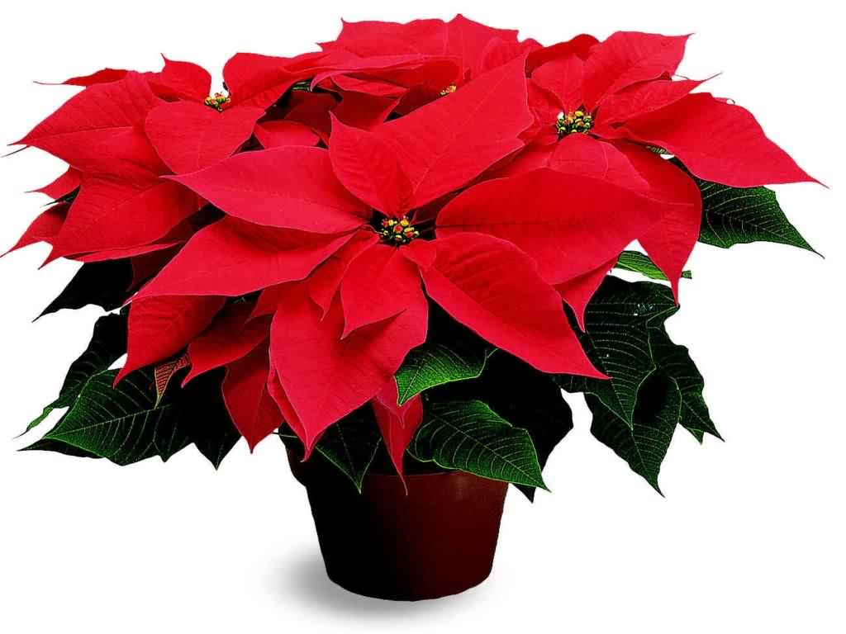
This Photo by Unknown Author is licensed under CC BY-ND
Holiday Poinsettias can be ordered up till December 2nd by signing up in the church foyer or calling Sandy Bonavina (570 829-7747) $7 each

Updates from the Official Board:
Individual Boards will meet on Thursday, December 9th at 6 PM with the Official Board Meeting to follow at 7 PM.
Special Important Congregational Meeting
December 12th after Sunday Worship

A quorum is required to vote on Church Bylaw issue and approve nominations for church officers.
Please plan to attend.

What Kind Of Bone Are You?
It’s been said that the “body” of a church has four kinds of bones:
- The WISHbones – those who wish someone else would do all the work.
- The JAWbones – who do all the talking and very little else.
- The KNUCKLEbones – who knock everything anyone else tries to do.
- The BACKbones – who get under the load and get the work done.

There are vacancies on all church boards. If anyone is willing or interested in serving on one of the boards (Deacons; Trustees; or Christian Education), your help would be greatly appreciated! (No experience required – only willingness to serve).
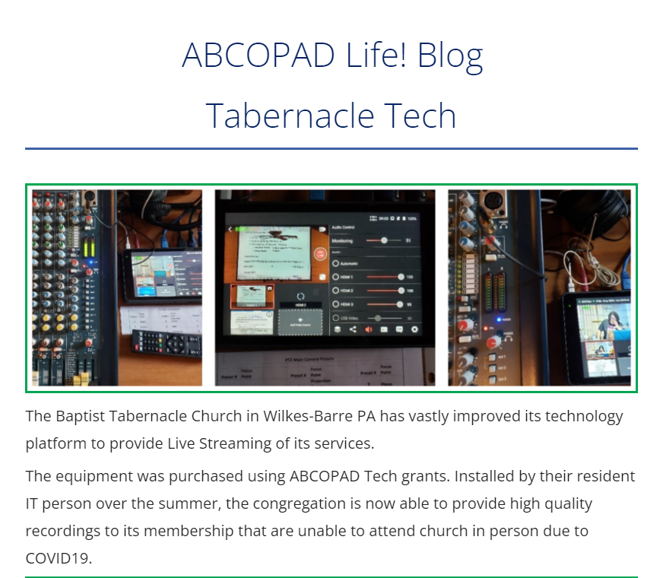
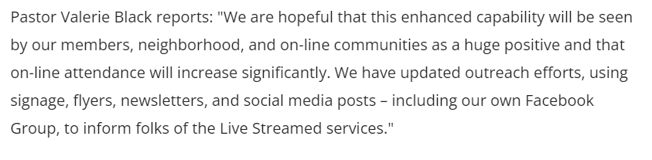
Meetings/ Events:
November 20: Decorate Sanctuary for Christmas
This Photo
by Unknown Author is licensed under CC BY-NC
Advent Sundays: November 28; December 5; 12; and 19
December 2 (Thursday) Final Day to order Pointsettias
December 5 (Sunday) Communion. Children’s Sunday School (10:45 AM)
December 9 Church Board mtgs. 6pm; Official Board Meeting 7pm
December 12 Important Congregational Meeting (after service)
December 19 Christmas Sunday
Children’s Sunday School (10:45 AM)
December 24 Candlelight Christmas Eve Service 6pm 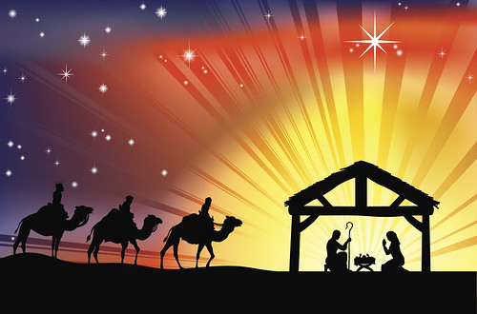
This Photo by Unknown Author is licensed under CC BY-SA
Birthdays and Anniversaries:
November
27 Sharon Myers
28 Linda Shandorf
30 Matthew Cannavale
December
2 Kristen Finnegan
9 Judy Tudgay
20 Earl & Erma Kohl (anniv)
31 William Finnegan
Covid-19 Update:
Though not required, current Covid Guidelines recommend that masks be worn by both vaccinated and unvaccinated people when indoors in order to reduce the risk of transmitting the virus. Christmas Eve service – ALL folks should mask to protect others.
Our goal is to provide a safe opportunity for as many people as possible to participate in the Sunday worship service. Live-streaming will continue for those who are unable to participate in-person.
Communion
If anyone is interested in receiving communion at home, disposable communion cups are available and can be picked up at the church. Contact Ron Shandorf or Bettie Sims to make arrangements to pick up communion cups. Pastor Valerie can offer communion via phone or arrange for a personal visit for our shut-ins.

Live Streaming Services:
Live streaming can be done on any internet device including smart phones; iPads; tablets; or computers. If you have any questions about how to access live streaming, you can call Ron Shandorf at 610 462-8476.
To access the live streaming, you can choose one of two options:
- Go to the church website: wbtabernacle.com and click on the link for live streaming. You can choose the service you would like to view.
- Go to YouTube and search for “Baptist Tabernacle Church-WB”. You can select the service you would like to view.

Key Contact Info:
Website: wbtabernacle.com
YouTube Channel: Search YouTube for “Baptist Tabernacle Church-WB”
Facebook: Search for “Group” = “Baptist Tabernacle” and Join the group
Name Email Address Phone #
Pastor Valerie Black PastorWBTabernacle@Outlook.com (570) 877-2975
Tech issues – Ron Shandorf IT.WBTabernacle@Gmail.com (610) 462-8476
Bea Fell BeaFell93@Gmail.com (570) 301-8073
Don Ostrander Dgunnyo@Comcast.net (570) 817-6835
Janet Murray JanetMurray07@Gmail.com (914)260-9066

