Baptist Tabernacle 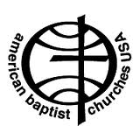
Baptist Tabernacle
63 Division Street
Wilkes-Barre, PA 18706
570 823-3083
Website: www.wbtabernacle.com
YouTube Channel: Baptist Tabernacle Church – WB
Email: Pastor.WBTabernacle@Gmail.com

Tabernacle Tidings
February 2022
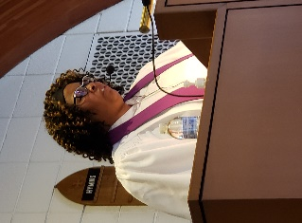
Message from Pastor Valerie
LET LOVE RULE
During the month of February, we celebrate Groundhog Day, Valentine’s Day, President’s Day, and Black History Month. It is supposed to be a month of celebration, love, history, and remembrance. But recently, fourteen Historically Black Colleges and Universities received bomb threats, which is an act of hate and terror. Some juveniles have been arrested for these hate crimes. This has caused me to reflect on something that Reverend Doctor Martin Luther King, Jr. said “I have decided to stick with love. Hate is too great a burden to bear.” There seems to be a lot of hate going around in the world today. I know that it can be frustrating and can cause us to hate also. But I refuse to let hate win. I choose to love. In the Gospel According to John 13th Chapter, 34th and 35th verses Jesus is quoted as saying, “A new command I give you: Love one another. As I have loved you, so you must love one another. By this everyone will know that you are my disciples, if you love one another.” Our Lord, Savior, and Master commands us to love, not only in the good times, but also during the difficult ones. He never said that it would be easy, but through Him it is possible. So, my message to you is to “Let Love Rule.”
Be Blessed,
Pastor Val
If anyone needs pastoral support, please feel free to call or email Pastor Valerie
Phone: 570 877-2975
Email: Pastor.WBTabernacle@Gmail.com
On February 2nd, the Groundhog saw his shadow and sadly we are expecting 6 more weeks of winter… Let’s pray that the prediction is wrong and we start seeing signs of spring soon.

We are continuing to keep Mary and Wayne Hauer in our thoughts and prayers as a tragic fire destroyed their home in mid-January. They have been staying with family.

We were joined by Rev. Mark Mahserjian-Smith at Sunday service last week. He requested that we keep ABCOPAD in prayer while they are seeking to fill vital leadership roles. Please take a moment at 8:22 PM each day (2022 military time) to think about and pray for ABCOPAD during this time of transition.

Mission focus for January and February is the Retired Ministers and Missionaries Offering.

February 14th is Valentine’s Day
Let all that you do be done in Love 1 Corinthians 16:14

Happy Valentine’s Day
Valentine Art by Ella Grilz
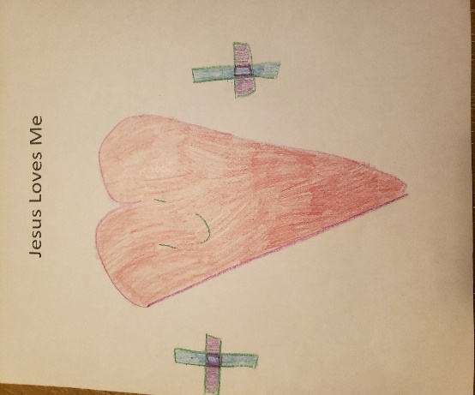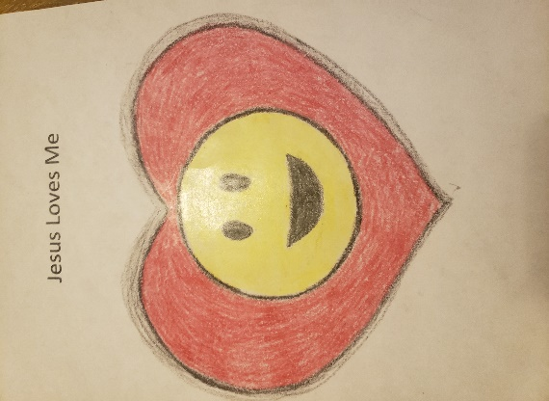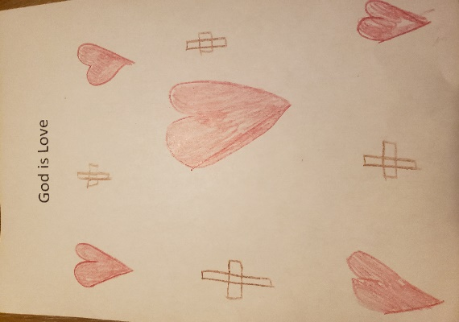
A new commandment I give you: Love one another. As I have loved you, so you must love one another. John 13:34

Meetings/ Events:
February 10th Board Meetings: Individual boards 6 PM Official Board 7 PM
February 13th All Annual Reports due (2021) to church office for collating, copying and preparation.
February 6th and 20th Bible Study following Sunday Service
(Bible Study: Victory in Spiritual Warfare by Tony Evans)
February 13th Kids Sunday School 11AM - 12PM
February 26th Pastor Val is singing in a program of Gospel Music at the Ritz Theater in Scranton 6-8 PM
February 27th Congregational Business Meeting
Budget approval and Annual Report distribution.

Birthdays and Anniversaries: February
4 Angelica Saltz 16 Bea Fell
4 Megan Sims 20 Larry Miscavage
9 Antonio Bonavina 26 Wayne Hauer
9 Anna Murray 28 Paula Delprete
13 Connor Leiby

Covid-19 Update:
Covid 19 was first reported in the United States in January 2020… just about 2 years ago. The pandemic has impacted all of our lives and it’s hard to believe the changes we’ve endured. Vaccines were developed in 2021 and though the covid 19 virus transmission continues to affect so many, we are seeing that people who have received the initial and booster shots are less likely to develop severe illness requiring hospitalization. We are grateful that we have been able to resume in-person worship and have been able to keep in touch with church members through live streaming and the monthly newsletter.

Though not required, current Covid Guidelines recommend that masks be worn by both vaccinated and unvaccinated people when indoors in order to reduce the risk of transmitting the virus (especially with the Omicron strain). ALL folks are advised to mask to protect others.
Our goal is to provide a safe opportunity for as many people as possible to participate in the Sunday worship service. Live-streaming will continue for those who are unable to participate in-person.
Communion
If anyone is interested in receiving communion at home, disposable communion cups are available and can be picked up at the church. Contact Ron Shandorf or Bettie Sims to make arrangements to pick up communion cups. Pastor Valerie can offer communion via phone or arrange for a personal visit for our shut-ins.

Live Streaming Services:
Live streaming can be done on any internet device including smart phones; iPads; tablets; or computers. If you have any questions about how to access live streaming, you can call Ron Shandorf at 610 462-8476.
To access the live streaming, you can choose one of two options:
- Go to the church website: wbtabernacle.com and click on the link for live streaming. You can choose the service you would like to view.
- Go to YouTube and search for “Baptist Tabernacle Church-WB”. You can select the service you would like to view.

Key Contact Info:
Website: wbtabernacle.com
YouTube Channel: Search YouTube for “Baptist Tabernacle Church-WB”
Facebook: Search for “Group” = “Baptist Tabernacle” and Join the group
Name Email Address Phone #
Pastor Valerie Black Pastor.WBTabernacle@Gmail.com (570) 877-2975
Tech issues – Ron Shandorf IT.WBTabernacle@Gmail.com (610) 462-8476
Bea Fell BeaFell93@Gmail.com (570) 301-8073
Ron Shandorf Ron@Shandorf.com (610) 462-8476
Janet Murray JanetMurray07@Gmail.com (914)260-9066

