Baptist Tabernacle 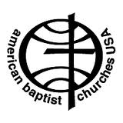
Baptist Tabernacle
63 Division Street
Wilkes-Barre, PA 18706
570 823-3083
Website: www.wbtabernacle.com
YouTube Channel: Baptist Tabernacle Church – WB
Email: Pastor.WBTabernacle@Gmail.com

Tabernacle Tidings
November/ December
2022
Holiday Holidays !!!
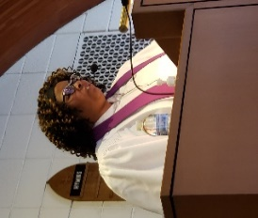 Message from Pastor Valerie

WHAT REALLY MATTERS
During this Holiday Season, we may find ourselves hustling and bustling to prepare for Thanksgiving, Christmas and yes even New Years. It may seem as though we have so much to do and not enough time to do it. We have to get all of the fixings for Thanksgiving Dinner, decorate our homes, do our Christmas shopping, get the food for Christmas Eve and/or Christmas Day, and everything we need for News Years Eve and New Years Day. The list of errands may seem endless and time may seem short, but I want to encourage you to take a moment, maybe even two moments to stop and think about what really matters during this Holiday Season as we try to come out of this Global Pandemic. Think about it, we are able to come together as friends and families to express our thanks to God, who has brought us through these troubling times. We are able to come together and celebrate the birth of His Son, Jesus, who came to this Earth to be our example of Godly living, preach the Good News, die for our sins, be resurrected from the dead, and ascend to Heaven. We are able to come together and celebrate coming out of 2022 and going into 2023 with our life, our health, and our strength. So, during this Holiday Season, let’s remind our families and friends about what really matters.
Happy Thanksgiving! Merry Christmas! Happy New Year!
Pastor Val
Best wishes to all for a very happy Thanksgiving. Hoping that you are able to spend time with family and friends this holiday season.

Happy THANKSGIVING

Psalm 107:21
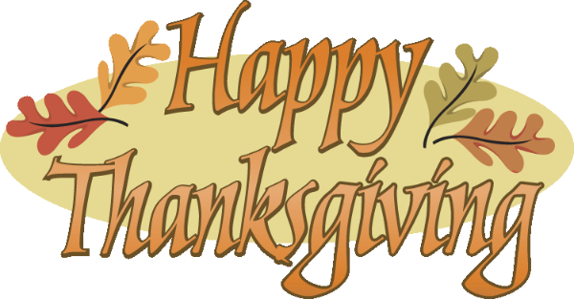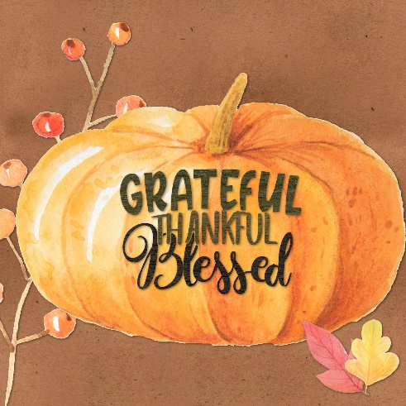
This Photo by Unknown Author is licensed under CC BY-NC

Top Thanksgiving Bible Verses
"Oh give thanks to the Lord, for he is good, for his steadfast love endures forever!" (Psalm 107:1)
"I will give to the Lord the thanks due to his righteousness, and I will sing praise to the name of the Lord, the Most High." (Psalm 7:17)
"Give thanks in all circumstances; for this is the will of God in Christ Jesus for you" (1 Thessalonians 5:18)
"Do not be anxious about anything, but in everything by prayer and supplication with thanksgiving let your requests be made known to God." (Philippians 4:6)
"And let the peace of Christ rule in your hearts, to which indeed you were called in one body. And be thankful." (Colossians 3:15)
Preparing for Christmas
The Spirit of Giving

“It’s not how much we give but how much we put into giving” Mother Theresa

Let’s take time this Christmas season to think of ways to reach out and serve others.
Consider Volunteering to help the elderly or homeless.
Donate to the local food pantry.
Try to think of random acts of kindness and ways to help neighbors, family and friends.

As a church we will be sponsoring the hat, scarf and glove tree.
This Photo by Unknown Author is licensed under CC BY

As an outreach effort, we will sponsor the following neighborhood activity:
This Photo by Unknown Author is licensed under CC BY-NC-ND
Neighborhood Christmas Cheer: December 10th 2 -4 PM
Please plan to join us as we share Christmas joy with our neighbors. We will be serving Hot Chocolate and Coffee and giving away Holiday Treats while we sing Christmas Carols and make a special holiday craft.

Contact Sandy Bonavina to order a poinsettia for Christmas. (sign up sheet in church narthex) You must specify your preference for red, pink, or white. $7 each. All orders must be submitted by Dec. 4th.

White Cross Project:
Women on a Mission’s White Cross project, please give your $$$ donation to any member of Women on a Mission. Our deepest gratitude for your part in this 100+ years of White Cross ministries!

CH RCH
What’s Missing? … You
This Photo by Unknown Author is licensed under CC BY-SA

In 2022, we were able to accomplish many great things for Baptist Tabernacle with only a few workers. But the church is only as good as its “People”. WE NEED YOUR HELP!!
Please volunteer to serve on a church board or committee.
All Boards are in need of members.
Deacons: coordinates church worship services and pastoral related activities
Trustees: deals with church business and building maintenance issues
Christian Education: Plans education program and events for children and Sunday School curriculum.

Constitution and ByLaws
The Constitution and By Laws have been revised by the By Laws Committee with suggested changes. They have been approved by the Official Board, so a Congregational Business Meeting will be held for approval.
A copy of the revised Constitution and By Laws is being mailed to all current church member households.

Prayer List:
Seasoned Saints: Margaret Bullock, Arleen Ebert, Beatrice Murray, Peggy Breese, Bob & Elaine Singer, Mrs. Brezinski,

Jane Tudgay’s family and friends; Merissa’s family and friends; Eric’s Family; Joann’s family and friends; Judy Dawe; Kenny; Clara Haynes; Charlotte Ledbetter; Ruth Black; Gloria Watson; Robin; Leanne; Shanette Black; Barb’s family; Bettie Sims; Matt & Amy; Andrea, Ella & Jase; Erma Kohl; Wayne and Mary Hauer; Mary’s Mom Nancy; Sandip; Matthew Kobusky; Sylvia Parker; Linda Evans; Eddie; Amber; Andrew; Debbie; Theresa; Bill Beebe
People with special needs; Relief from Ian & flooding; Mass Shooting victims; World trouble spots including Ukraine.

Updates from the Official Boards:
Deacons: A 4 week Bible Study of Romans by Max Locado has been meeting on Tuesday evenings. Plans are still being discussed regarding sponsoring an Active Shooter Training. There will not be a special Thanksgiving service this year. Christmas flowers will be sent to our shut ins. Plans are being made for advent services and activities. We will be having worship services on both Christmas Eve and Christmas Day.
Board of Education: The Pumpkin Giveaway was a great success! Kids (and parents) stopped by to pick a pumpkin and many stayed to paint and decorate their special harvest creation. Great fun! Neighborhood Christmas caroling is planned for December 10th. Children will be participating in the Christmas Eve service this year.

Trustees: Committee members continue to evaluate building maintenance needs.

Meetings/ Events:
November 9 (Wed.) Boards meet at 6 PM Official Board meets at 7 PM
November 13 Abington Association Hymn Sing and Meeting at 2 PM
(Abington Baptist Church)
November 20 Decorate Church for Advent immediately following service
December 4 Christmas Poinsettia orders are due
December 8 Boards meet at 6PM Official Board meets at 7PM
December 10 Neighborhood Christmas Cheer & Caroling 3 PM
December 11 Important Congregational Meeting: Election of Officers and vote on Constitution and By Law amendments
December 24 Christmas Eve candlelight service at 5 PM
December 25 Christmas Sunday Worship

Birthdays and Anniversaries:
November:
5 Paula DelPrete & Paul Durko (anniv.) 27 Sharon Myers
10 Janet Cussatt 28 Linda Shandorf
13 Marcus Gudaitis 30 Matthew Cannavale
18 Noah Cussatt

December:
2 Kristen Finnegan
9 Judy Tudgay
7 Earl and Erma Kohl (anniv.)
31 William Finnegan

Please remember our members who are sick or shut in by sending greeting cards.
Beatrice Murray Arleen Ebert
Timber Ridge Rm # 241 42 W Division St
1555 East End Blvd Hanover Township, PA 18706
Wilkes-Barre, PA 18711

Live Streaming:
Live streaming can be done on any internet device including smart phones; iPads; tablets; or computers. If you have any questions about how to access live streaming, you can call Ron Shandorf at 610 462-8476.
To access the live streaming, you can choose one of two options:
- Go to the church website: wbtabernacle.com and click on the link for live streaming. You can choose the service you would like to view.
- Go to YouTube and search for “Baptist Tabernacle Church-WB”. You can select the service you would like to view.

Key Contact Info:
Website: wbtabernacle.com
YouTube Channel: Search YouTube for “Baptist Tabernacle Church-WB”
Facebook: Search for “Group” = “Baptist Tabernacle” and Join the group
Name Email Address Phone #
Pastor Valerie Black Pastor.WBTabernacle@Gmail.com (570) 877-2975
Tech issues – Ron Shandorf IT.WBTabernacle@Gmail.com (610) 462-8476
Bea Fell BeaFell93@Gmail.com (570) 301-8073
Ron Shandorf Ron@Shandorf.com (610) 462-8476
Janet Murray JanetMurray07@Gmail.com (914)260-9066

